Advanced Computer Networks LAB
Spring Semester 2026
Assignment 4
Name – Soham Chakraborty
Roll No – 22CS02002

1. Packet Identification and Addressing –
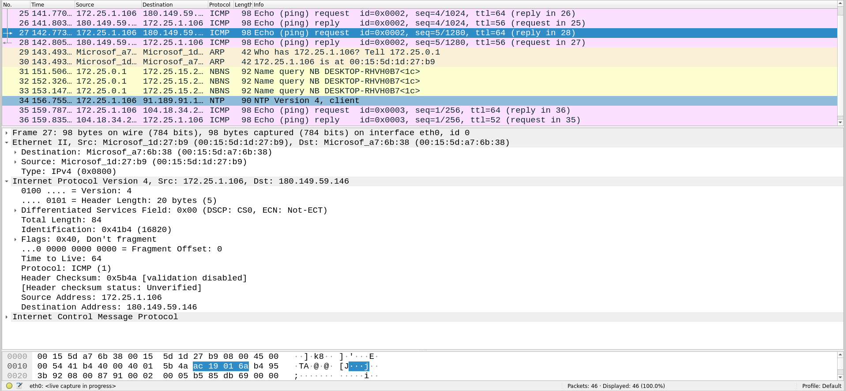

2. Traffic Clustering and Analysis –
Ans – 1)
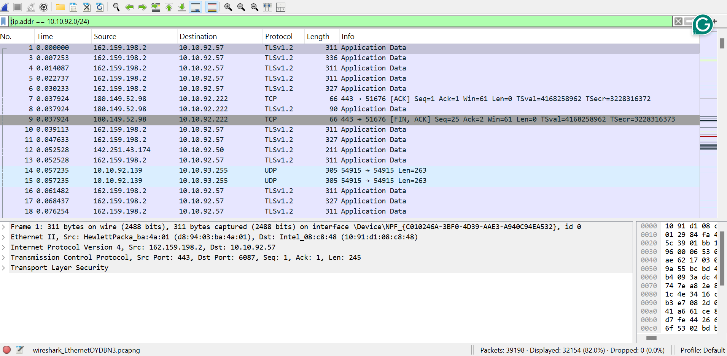
- Local Network (Same Subnet) 82%

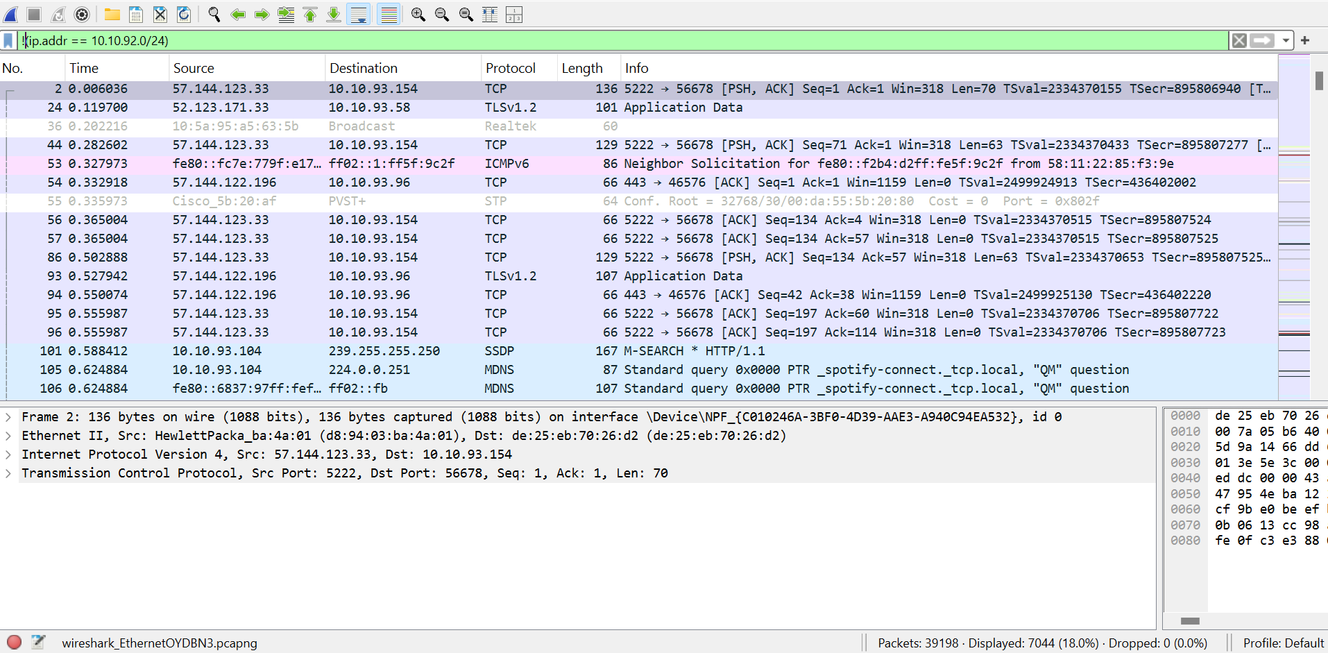
- External Network (Internet) 18%

Ans – 2) Router MAC = d8:94:03:ba:4a:01
- 98.4% of packets going to Router/Gateway
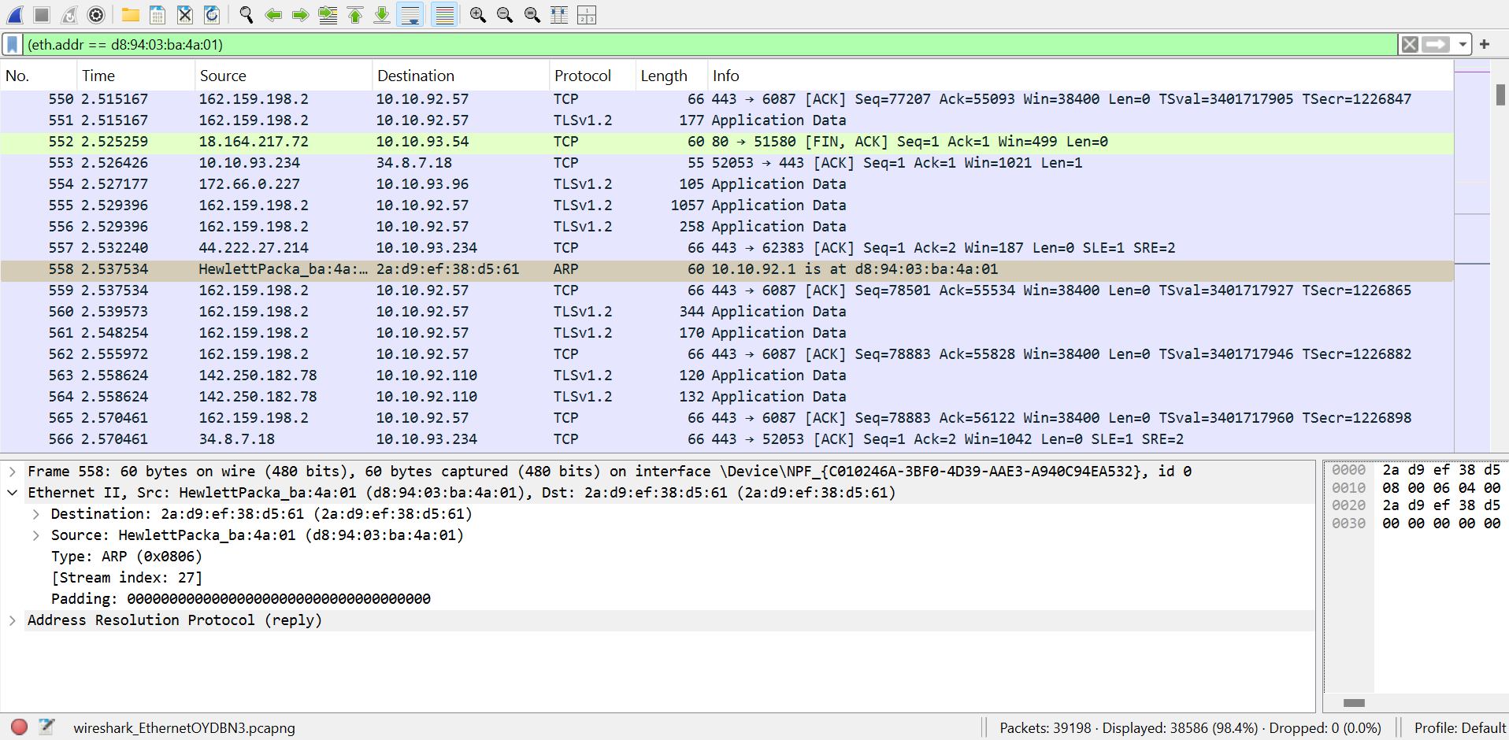

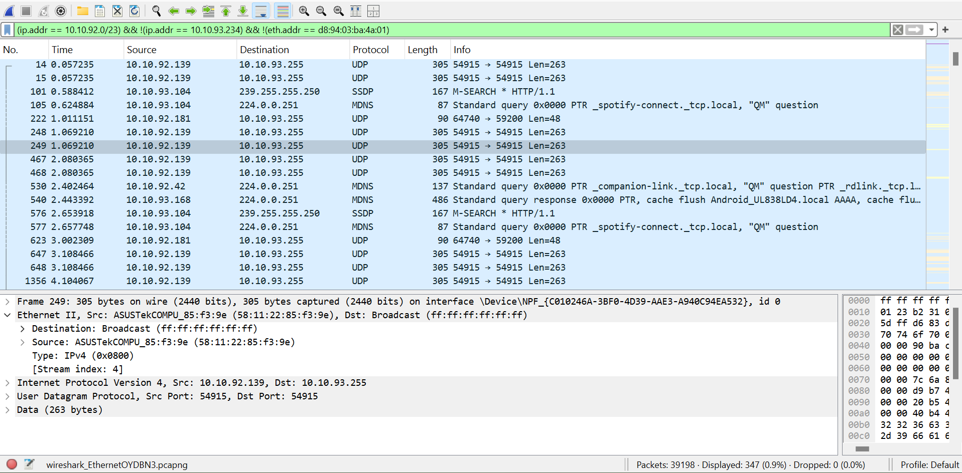
- 0.9% of packets going to other local machines

Ans – 3) My MAC = b4:45:06:7a:81:a7
- 5.1% packets where source or destination is my MAC address
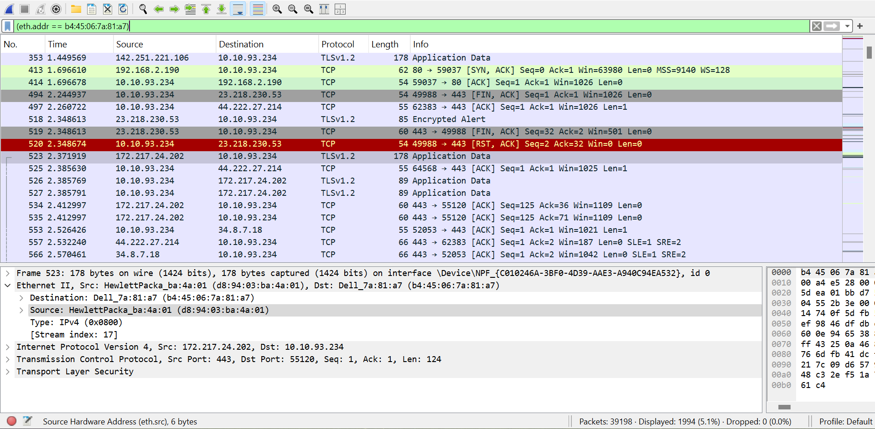

- 2.8% packets coming from internet to my machine
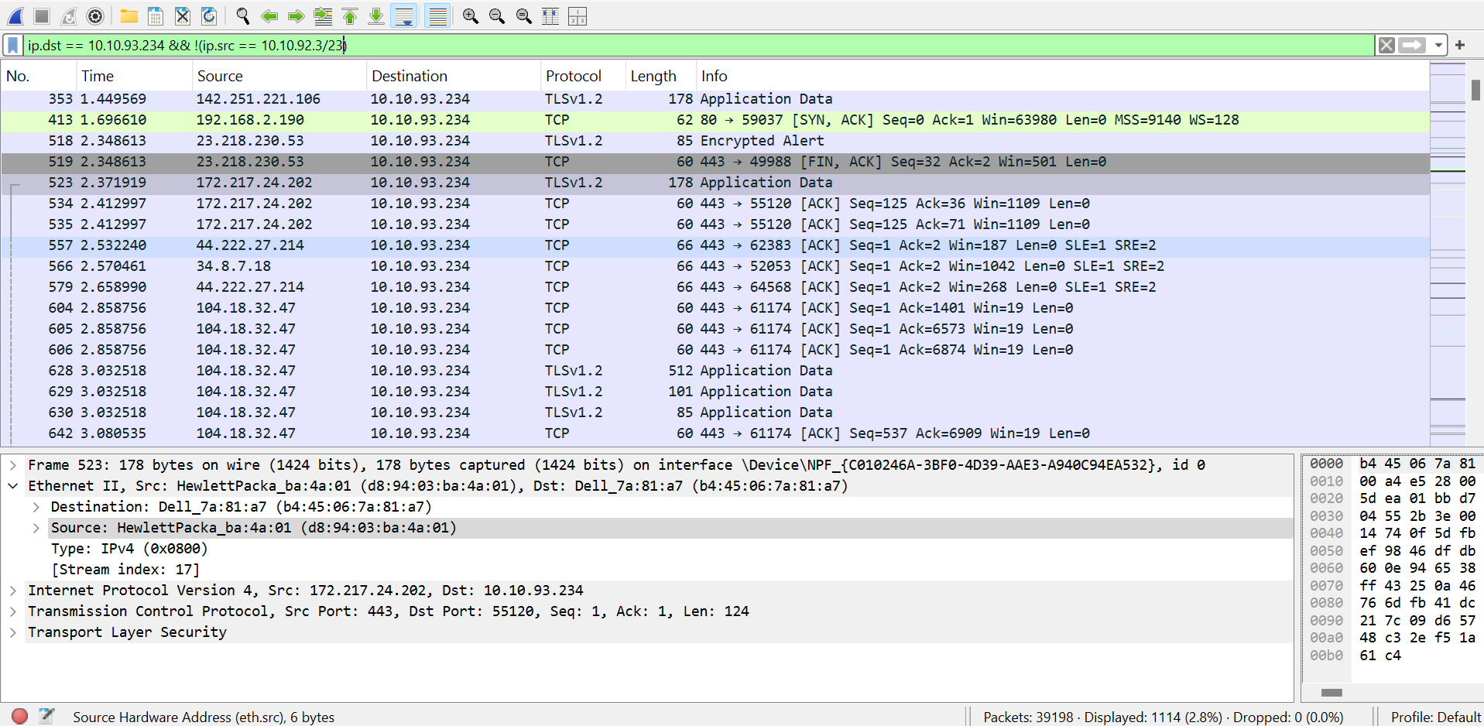

3. Protocol-Based Analysis (TCP/UDP) –
Ans – 1) Filters
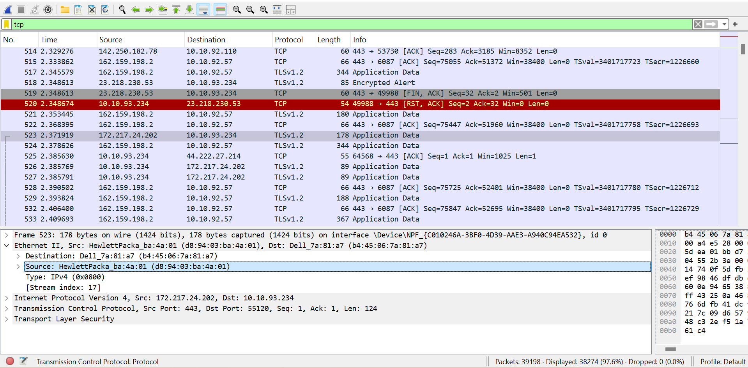
- 97.6% packets using TCP

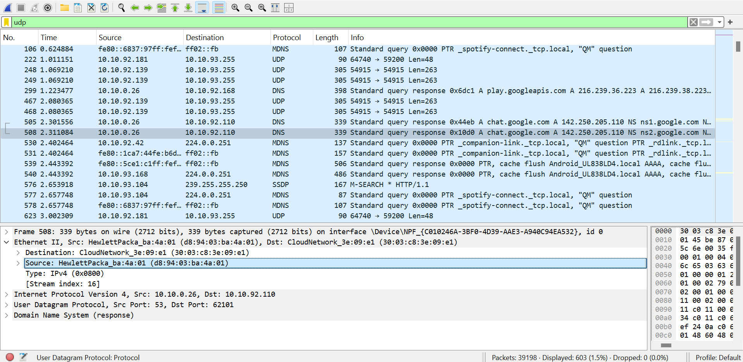
- 1.5% packet using UDP

Ans – 2)
- TCP Connection using Follow [SYN] TCP stream.
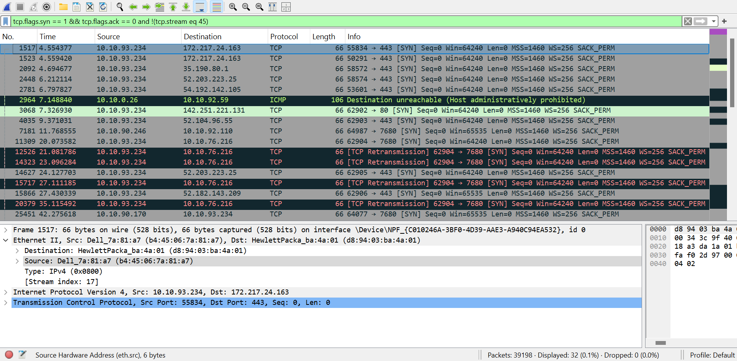

- UDP – dns communication.
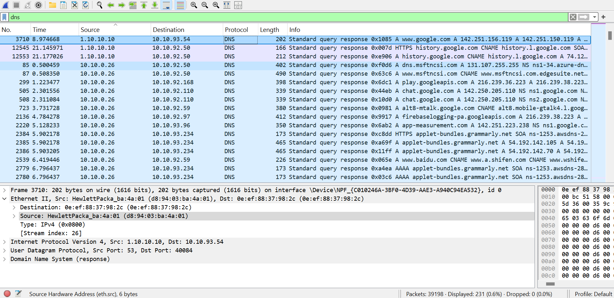

Ans – 3) In TCP there are packets of types [SYN] , [SYN, ACK] and [ACK], this confirms the 3-way handshake.
However, in UDP there is no such organized connection. We have only DNS query and Response.

Part 1: HTTP Sniffing and Security awareness –
Ans – 1) http://testaspnet.vulnweb.com/login.aspx has some server side error so I will have to work only based on GET and Internal Server Error.
- HTTP Request packet GET
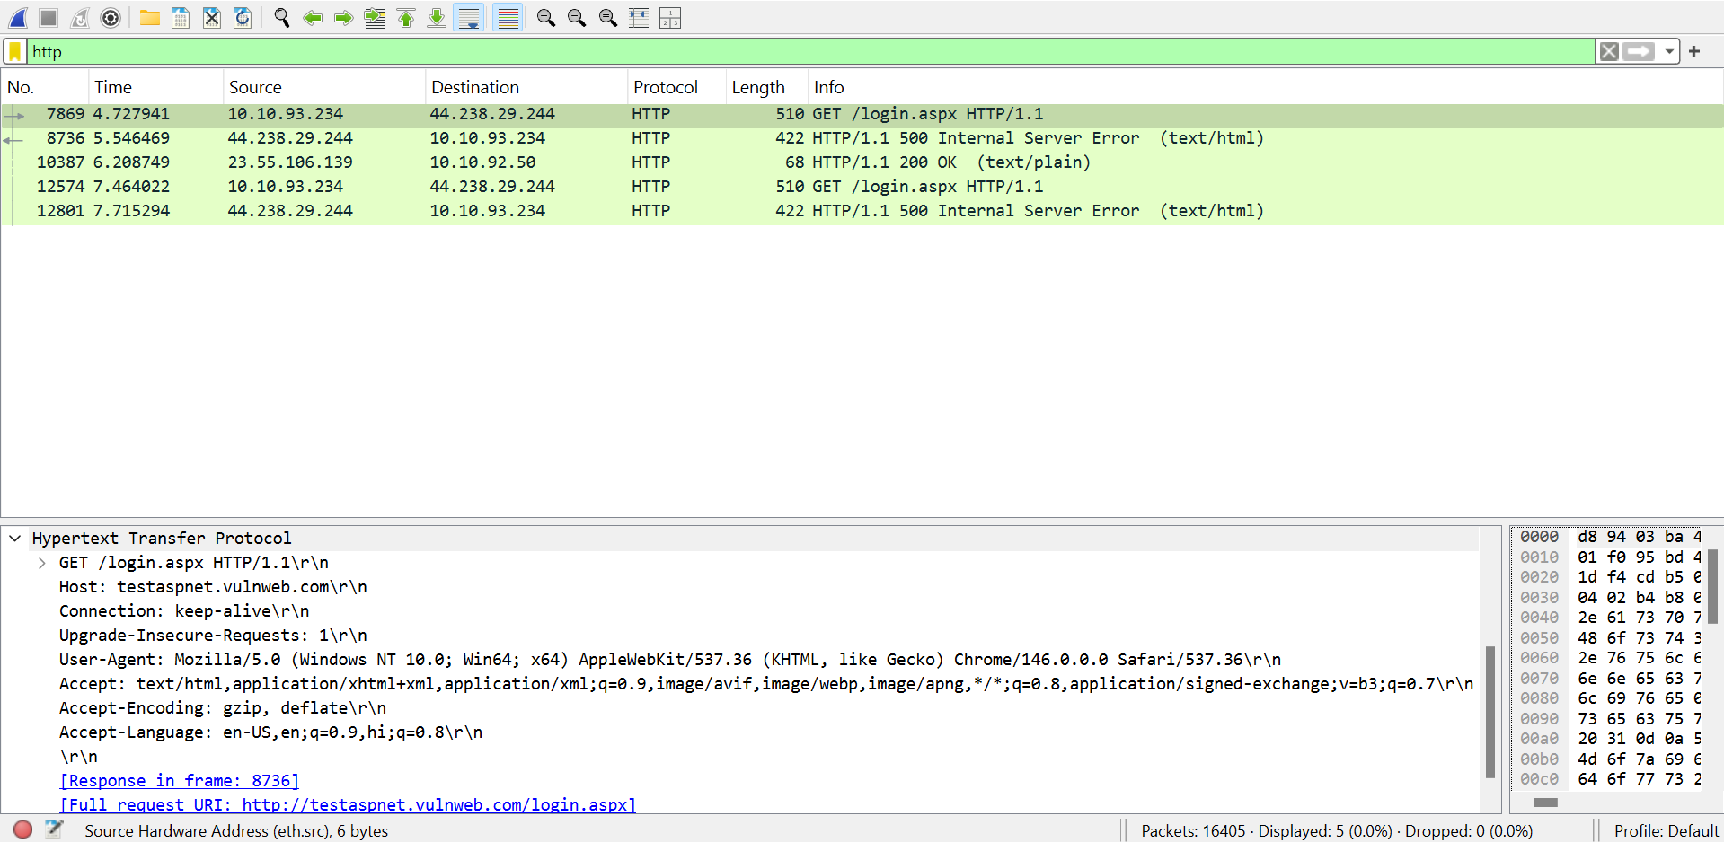

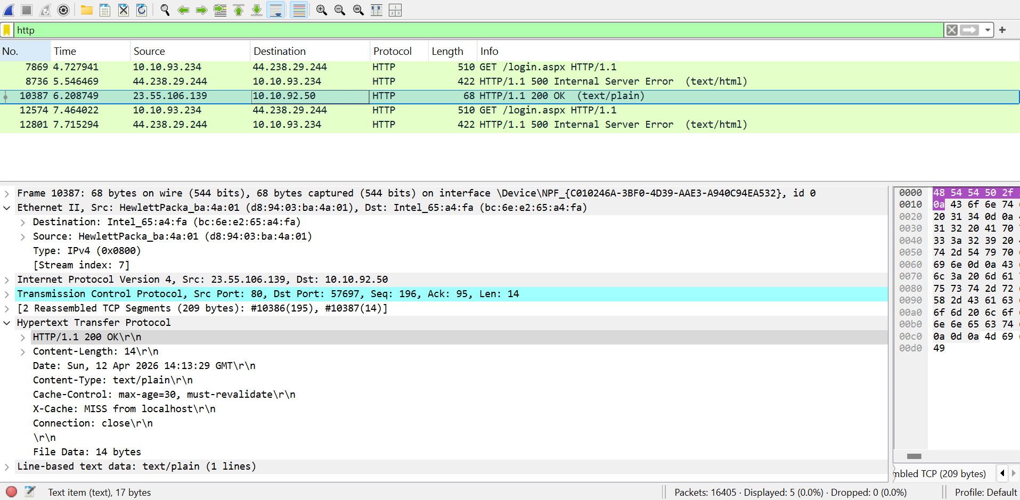
- HTTP Response packet 200 OK (text/plain)

Ans – 2)
- Requested URL from HTTP request packet details -
http://testaspnet.vulnweb.com/login.aspx
- Server Response code from HTTP Response packets –
500 Internal Server Error and 200 OK.

Part 2: Sniffing based script –
Given website (http://testaspnet.vulnweb.com/login.aspx) is not working.
I tried another website - http://testphp.vulnweb.com/login.php.
But this was also not working. So further writing a Script and POST login credentials was not possible.
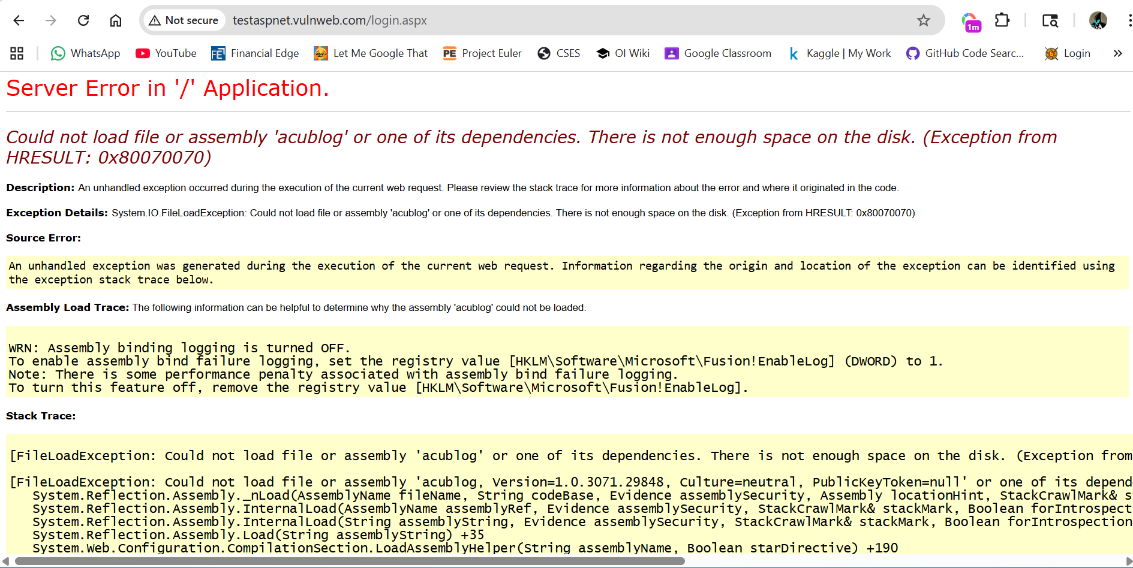
Error Screenshot of Website -

